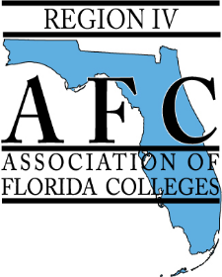

Call for Presentation Proposals
for
Region IV 2020 Spring Conference: “Dedicated to Success”
on April 3, 2020
at Pasco-Hernando State College: Porter Campus at Wiregrass Ranch

Our Region IV Chapters- Florida SouthWestern State College, Hillsborough Community College, Pasco-Hernando State College, Polk State College, St. Petersburg College, South Florida State College, and State College of Florida, Manatee-Sarasota cordially invite you to submit a presentation proposal for the annual Region Conference. The AFC Region IV seeks proposals for presentations that focus on the conference’s theme "Dedicated to Success” and any workshop that aligns with the goals and objectives of AFC. Presentations can be related to technology, curriculum, administration, employee benefits, self-care, student development, recruitment and retention.

On this day, more than 100 administrators, faculty and staff members from our Florida College System will attend this conference. Our members are from diverse professional backgrounds, representing all college areas such as faculty, administration, finance, public relations, technology, maintenance, athletics, professional development, institutional research, and student development.

All submissions will be evaluated by the Region IV Conference Planning Committee. Deadline for submission of abstracts will be February 14, 2020. You will be notified of the review committee’s decision by February 24, 2020.

Send proposals with the words “Proposal for AFC Region IV 2020 Region Conference” in the subject heading to: Mildred Diaz Santiago of Pasco-Hernando State College at diazsam@phsc.edu or Jaimie Pagels of Pasco-Hernando State College- at pagelsj@phsc.edu

Submission due by February 14, 2020

Name of presenter(s) and Job Title(s):

Contact Information:

Abstract of presentation (150 words or less):

Bio of Presenter(s) (100 words or less):

Technology needs (laptop, audiovisual equipment, etc.):

