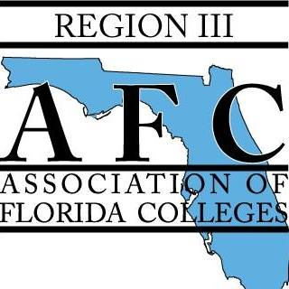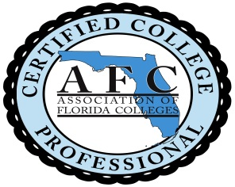
3 CCP for Region III
Nominee should be an active member within your chapter who is interested in learning more about the Association of Florida Colleges and the Florida College System.
Completed form must be returned to Kim Sellers no later than August, 15 2019. Submissions received after this date will not be considered.

NAME:_____________________________________________
COLLEGE:___________________________________________
NOMINATED BY:_____________________________________
Please provide a short bio of the nominee including any participation within AFC.
________________________________________________________________________________________________________________________________________________________________________________________________________________________________________________________________________________________________________________________________________________________________________________________________________________________________________________________________________________

Kim Sellers Director, Region III sellersk@cf.edu 352-873-5806

