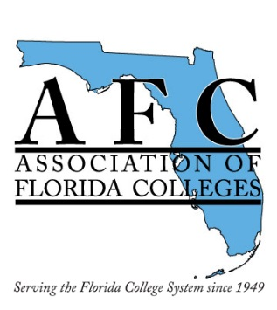
NW Campus, 3000 NW 83rd Street, Gainesville, FL

Friday, April 1, 2016

Region II Spring Conference: Connect, Collaborate…Take Action!
8:30-9:00 AM |  | Registration – Fine Arts Hall Lobby
9:00-9:30 AM |  | Welcome and Introductions  Heather Jones  Rebecca Rogers  Dr. Sasser, President, Santa Fe College  Juanita Scott, AFC President
9:30-10:00 |  | Keynote Speaker/Service Project – Fine Arts Hall Lobby  Dr. Bea Awoniyi  Theresa Lowe, Executive Director of the North Central Florida Coalition for the Homeless and Hungry
10:00-10:15 |  | Break
10:15-11:00 |  | Career and Professional Employees Commission: CPEC 101 | Design Out Crime, Design In Safety  Chief Ed Book | Leveraging Administrative Leadership for Academic Success  Y-130  Jametoria Burton
11:00-11:15 |  | Break
11:15-11:30 |  | Legislative Update: Liam McClay – Fine Arts Hall Lobby
11:30-12:45 |  | Lunch – Fine Arts Hall Dance Studio  Membership Committee Meeting  Campus Safety Commission Meeting
1:00-1:45 |  | Bringing Human Rights to Life Session 1 of 2 | Working and Communicating with Disruptive Individuals | Membership Committee Workshop Y-102
1:45-2:00 |  | Break
2:00-2:45 |  | Bringing Human Rights to Life Session 2 of 2 | Reimagining the Campus Tour  Adrienne Provost | Facilities: Access Control and Related Door Hardware (AIA CEU) Y-130  Assa Abloy
2:45-3:00 |  | Break
3:00-3:15 |  | Region II Business Meeting – Fine Arts Hall Lobby
3:15-3:30 |  | Door Prizes  50/50 Drawings
B-012 | A-012 | Library Y-102 & 130

