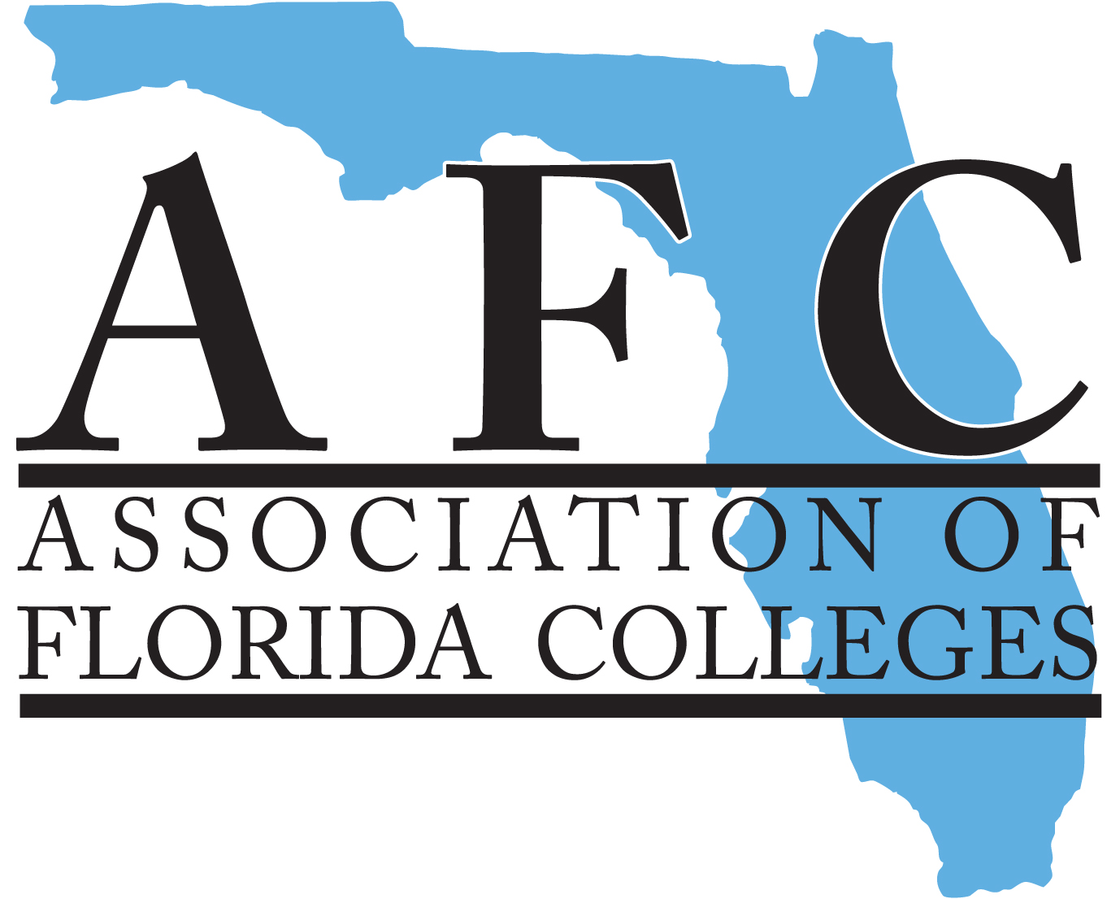  association of florida colleges  This Certifies That  Is a member of the Association of Florida Colleges  and is entitled to all the privileges of the Association as assigned by AFC’s Board of Directors  Expiration Date | association of florida colleges  This Certifies That  Is a member of the Association of Florida Colleges  and is entitled to all the privileges of the Association as assigned by AFC’s Board of Directors  Expiration Date
association of florida colleges  This Certifies That  Is a member of the Association of Florida Colleges  and is entitled to all the privileges of the Association as assigned by AFC’s Board of Directors  Expiration Date | association of florida colleges  This Certifies That  Is a member of the Association of Florida Colleges  and is entitled to all the privileges of the Association as assigned by AFC’s Board of Directors  Expiration Date
association of florida colleges  This Certifies That  Is a member of the Association of Florida Colleges  and is entitled to all the privileges of the Association as assigned by AFC’s Board of Directors  Expiration Date | association of florida colleges  This Certifies That  Is a member of the Association of Florida Colleges  and is entitled to all the privileges of the Association as assigned by AFC’s Board of Directors  Expiration Date
association of florida colleges  This Certifies That  Is a member of the Association of Florida Colleges  and is entitled to all the privileges of the Association as assigned by AFC’s Board of Directors  Expiration Date | association of florida colleges  This Certifies That  Is a member of the Association of Florida Colleges  and is entitled to all the privileges of the Association as assigned by AFC’s Board of Directors  Expiration Date
association of florida colleges  This Certifies That  Is a member of the Association of Florida Colleges  and is entitled to all the privileges of the Association as assigned by AFC’s Board of Directors  Expiration Date | association of florida colleges  This Certifies That  Is a member of the Association of Florida Colleges  and is entitled to all the privileges of the Association as assigned by AFC’s Board of Directors  Expiration Date

