AFC Signature Style Sheet
Introduction
The Association of Florida College’s Signature Style Sheet is designed to help you produce printed materials that reflect a professional and consistent image for the association. By following the guidelines, and using the resources provided on the AFC website (www.myafchome.org), your printed materials will be more cost-effective and easier to produce.
The Association of Florida Colleges represents all faculty, staff, administrators, trustees, presidents, and retirees from Florida's State College System. The Association consists of local campus-based Chapters, Commissions, and Regions lead by a Board of Directors. Membership is currently over 8,000 and moving upward. It is important that all parts of the association present one clear image through a coordinated identification program. A clear message and visual image highlight the fact that the Association of Florida Colleges is a multifaceted, but unified organization.
The graphic identity of the Association of Florida Colleges is the sum of all the visual impressions associated with name. With dozens of incompatible logos in use, our graphic identity needs consolidation and consistency. Every college, region, commission, and committee of the association has developed a reputation for superior performance and service. However, as our reputation has grown, so has our variety of logos and graphic identities. Our goal is for the association to have more consistency in identifying the association and its parts, while preserving the flexibility demanded by a decentralized association culture.
Your participation is appreciated as we work together to advance the Association of Florida Colleges. Questions can be directed to the Michael Brawer, Executive Director at 850-222-3222 or e-mailed to mbrawer@myafchome.org.

Signature System

The official Association of Florida Colleges trademark logo is known as the signature.


Primary Signature
The Association of Florida Colleges signature is the official logo for use on all association communications. The signature consists of three elements: a typographic rendition of the monogram "AFC", the words "Association of Florida Colleges”, and the graphic element the map of the State of Florida. These elements work together to create a graphic identity representation of the Association of Florida Colleges. Do not alter the signature artwork, aspect ratio or colors.

Signature with Themeline
The association’s themeline is “Serving the Florida College System since 1949”. The themeline appears under the full length of the signature to increase its visibility and reinforce the overall layout. It acts as a foundation, both in word and function. The themeline is used with the AFC signature whenever possible on publications and other external and internal communications. The themeline may be used independently of the AFC signature. The type font must be maintained.

General Usage Guidelines
The following guidelines govern the use of the association’s signature in all forms of communication, including but not limited to print and electronic media.
- The signature is the primary identifier of the association and is the essential means of visual communication.
- The signature should not be modified in any manner, including colors. These symbols may be reproduced only from original master copies at http://www.myafchome.org/facc/PresidentLogo.asp?SnID=1805335471
- The signature must be used as a prominent graphic element in all publications -- print and electronic -- affiliated with the association.
- Any affiliates (chapters, regions, commissions, committees) of the association wishing to use a specific identifier in conjunction with the association signature must have prior approval and must use it in accordance with the guidelines in this style sheet. Any changes, additions, or deletions to the AFC signature or secondary signature must be approved by the AFC Executive Director.
- In situations where outside partnerships exist, the trademark(s) or logo(s) of the partner or partners may be displayed in printed and electronic communications, but should be separated from the AFC signature by at least one half inch and should not be given prominence over the AFC mark. Graphic elements that appear to connect or combine the AFC trademark with other partnership logos or graphics should not be used.

Graphic Identities
Official colors are Pantone 292 (Blue) and Black.
Font: Adobe Caslon Pro
Maintaining the integrity of the association signature is important. It must be presented in a clear, consistent, and effective manner. Always use original digital art. The signature cannot be redrawn, re-proportioned or modified in any way.
All elements of the logo must be used; no parts may be removed. The blue of the logo is always Pantone 292 or its equivalent. The logo may be used as all black, all blue or a combination of these colors is necessary for reproduction purposes. Sample variations of color are below:
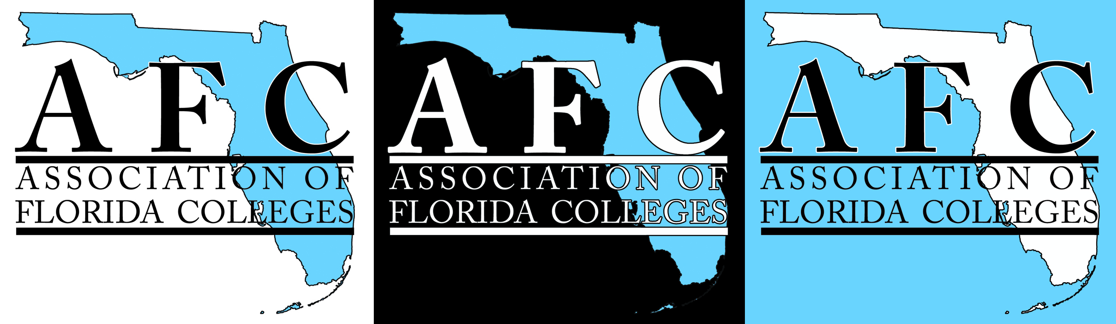

Secondary Signatures
These versions of the signature have been developed for use by chapters, commissions, regions and committees. By adding the unit name, the unit name receives prominence while retaining an overall association identity.
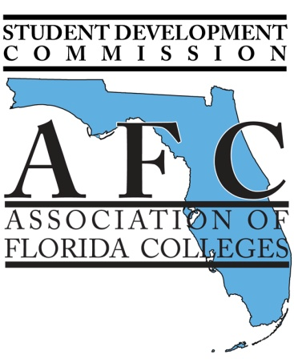
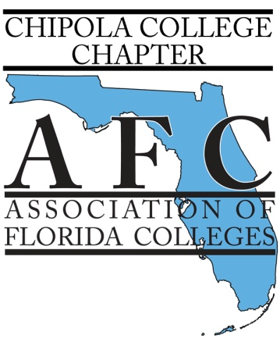
Secondary signatures are designed to offer a sub-identity for association entities while not changing the primary identity of the association. Any changes, additions, or deletions to the AFC signature or secondary signature must be approved by the AFC Executive Director.

Samples of

Secondary Signatures

Unique Logos and Graphic Elements
In the past, some chapters, commissions or regions have requested a unique logo design that is different from the Association of Florida College’s identity, to convey an emotion or message about a special project. While we understand the desire for unique logos, we know that having a single visual element resonates with our many audiences and provides quick, easy and consistent recognition. Therefore, approvals may be considered for a graphic element to be used on specialty promotional items, clothing and certain collateral material, as long as there is a clear visual separation and delineation between the AFC signature and the graphic element.

