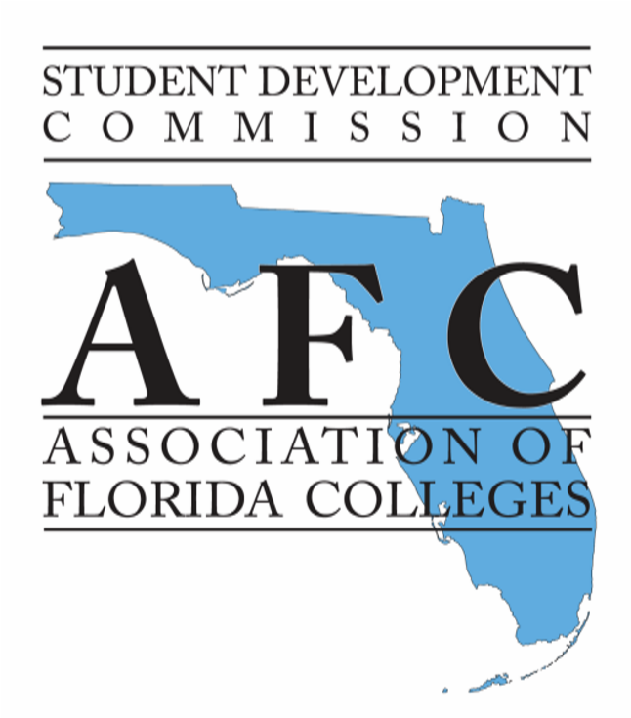

AFC STUDENT DEVELOPMENT COMMISSION 2016 EXEMPLARY PRACTICE AWARD

CALL FOR PROGRAMS

The AFC Student Development Commission is pleased to sponsor the 49th Annual Student Development Commission Exemplary Practice Award. The commission recognizes outstanding programs and professionals in the student development field and invites each Florida college to showcase its best programs.

We ask you to take a few minutes to think about the programs currently in place at your college. If your college has a program considered new and innovative or a program that illustrates exceptional student services, we encourage you to nominate one per campus. The program must have been in existence for at least 12 months prior to your submission.

A group of judges will meet to review the program submissions at the AFC Annual Meeting and Conference in Lake Buena Vista, Florida on November 11, 2015. Up to four finalists will be asked to present their entry at the 2016 Student Development Commission Spring Conference in Orlando, Florida.

Enclosed is an award form, a list of questions you must answer when preparing your entry, and instructions for writing your abstract. This information is also available at www.myAFChome.org. Click on “Commissions,” “Student Development,” and “Awards.” Please share this with all of your student development team members!

Please send your nominations no later than Monday, November 2, 2015 to lbuie@fscj.edu.

Sincerely,

Luther T. Buie
Exemplary Practice Chair, Student Development Commission

AFC STUDENT DEVELOPMENT COMMISSION 2016 EXEMPLARY PRACTICE AWARD FORM

(Please Type or Print)

Name or Title of Program:

________________________________________________________________________

Person(s) Submitting Packet:

__________________________________________________________________

__________________________________________________________________
Name(s) Title(s)

Name and Signature of the Chief Student Personnel Officer on the campus:

__________________________________________________________________
Name Signature

College Address:

__________________________________________________________________

__________________________________________________________________

__________________________________________________________________

Presenter(s) Telephone Number:

_______________________________________________________________________
Area Code/ Number Fax Number

Presenter(s) E-Mail Address:

________________________________________________________________________

Please scan and email to Luther T. Buie at lbuie@fscj.edu by Monday, November 2, 2015.

AFC
STUDENT DEVELOPMENT COMMISSION
2015 EXEMPLARY PRACTICE AWARD

Please type questions and answers.

- Name of the college and campus.

- Name and title of program.

- Name(s) and title(s) of practitioner(s) directly responsible for program.

- What date did the program originally begin? (Your exemplary practice must have been initiated at least 12 months before submission of this award form).

- Briefly describe the program.

- What need did this program meet that was not being met?

- How many and what type of people were served by this program?

- List the objectives of the program.

- How have the objectives been met?

- What was the cost of providing this program?

- What was the funding source?

- How did you justify the cost of this program? (Was it cost effective? Did you save money? Other financial benefits?)

- What was the institutional involvement, especially outside of Student Services, in establishing the program? What is the continued involvement?

- What are the results or findings from the evaluations?

- Has the program been changed, revised, or improved as a result of the evaluations?

- Please include a 250-word abstract describing your exemplary practice. The guidelines follow on page two.

Please include artifacts to enhance your exemplary practice submission. Examples of artifacts can include: pictures, posters, data, student handouts/materials, etc. This will help the judges conceptualize your program.
ABSTRACT FORMAT

The abstract should be no longer than 250 words. It should include:

- Background (Nature of college, community, and students).

- What problem(s) or need(s) is addressed in your exemplary practice?

- What results were achieved in students (i.e. motivation, performance competencies) and in the learning process?

- What materials are available to implement this practice at other institutions?

- Where can interested colleagues write, e-mail, and/or call to reach you?

