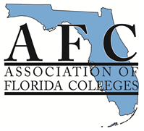
AFC LEARNING RESOURCES COMMISSION
2017 EXEMPLARY PRACTICE AWARDS
- Library Services
- Learning Support Services

The AFC Learning Resources Commission is pleased to sponsor the two Annual Learning Resources Commission Exemplary Practice Awards: 1) Library Services Award for MLS librarians, and 2) Learning Support Services Award for learning resource centers,tutoring or lab centers, academic support, or library support staff. The commission recognizes outstanding programs and professionals in the learning resources field and invites each Florida College to showcase its best programs.

We love to hear about new and innovative programs or a program that illustrates an exceptional practice in either library services (for MLS librarians) or learning support services (for support staff members). We encourage you to nominate one program per campus in either or both categories. The program must have been in existence for the 2016-2017 academic year (July 2016-June 2017). The nomination should include an abstract of the program and any supporting documentation. The nominee must also be a member of AFC by the application deadline to apply. The winner will be invited to present their entry at the AFC Fall Conference November 1-3, 2017 in Palm Harbor, FL, and the winner will receive up to $500.00.

In addition to the possibility to present your project at the fall conference, the Learning Resources Commission seeks projects to spotlight at the virtual conference on March 28th, 2017.

The nomination form and the judging criteria are included. A copy of this information is also available at http://www.myafchome.org.

Please share this with all of your learning resources team members!

Please send your nominations electronically no later than March 31, 2017.

Please call me with your questions at 772-336-6268 or email me at kauberry@irsc.edu.. I look forward to receiving your nominations.

Sincerely,

Kendra Auberry

Chair, Learning Resources Commission

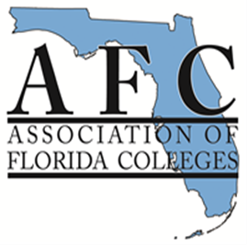
LEARNING RESOURCES COMMISSION
2017 EXEMPLARY PRACTICE AWARDS
Nomination Form
Complete and submit this form with your nomination.
Nominations must be submitted electronically to the Learning Resources Commission Chair by March 31, 2017.

Date:_________________________________________________________________________
Check one category:
___Library/Learning Resources Center Services
___Learning Support Services
Title of Nominee's Program:_____________________________________________________
Nominee’s Name:______________________________________________________________
Nominee's College:_______________________________Campus:______________________
Nominee’s E-Mail:_____________________________________________________________
Are you able to present at the Virtual Conference on April 21st? _____________________
Are you able to present at annual conference on November 1-3? ______________________
Reason for nomination: Attach a brief summary (not to exceed 1,000 words) about the program, including information that supports the criteria listed on the judging criteria page. Include any supporting documentation.
Deadline Date: March 31, 2017
Submit nomination form, brief summary and supporting documentation electronically to Commission Chair Kendra Auberry at kauberry@irsc.edu. You will receive a confirmation email once your application has been received.

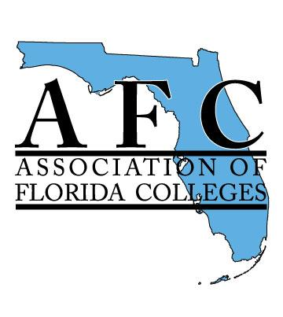
Association of Florida Colleges
Learning Resources Commission
Exemplary Practice Awards
Judging Criteria and Scoring Rubric
_____Library/Learning Resources Center Services
_____Learning Support Services
PURPOSE
The purpose of this award is to recognize exemplary practices in libraries and learning resources centers as well as learning support service centers within the colleges of the Florida College System. The award also serves to increase awareness of the role that libraries, learning resources centers, and learning support service centers play in student learning & success and in fulfilling the mission of Florida’s colleges.
Nominee’s Name:_____________________________________________________________________
Nominee's Institution:_________________________________________________________________
Title of Nominee's Practice:____________________________________________________________
Nominee’s Total Points:_______________________________________________________________
CRITERIA DESCRIPTION | Possible Points | Earned Points
PURPOSE | (50)
Degree that practice supports the mission of Florida College System and the Association of Florida Colleges | 10
Degree that practice supports student learning | 20
Degree that the practice has a marketing, public relations or advocacy outcome | 20
EXEMPLARY CRITERIA | (50)
Adaptability of idea – Can others easily adopt and adapt the practice? | 5
Illustrative quality of support materials – How well do the support materials demonstrate or explain the practice? | 5
Accountability/assessment of practice – Is there evidence that the practice is measurably making a difference? | 20
Innovation or originality of idea | 10
Recommendations by student(s), colleague(s) or faculty included that confirms or verifies that practice makes a difference/meets criteria (emails, notes, or formal letters) | 10
TOTAL POINTS | 100

