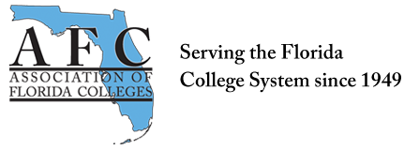
ADMINISTRATION COMMISSION MEETING
Indian River State College – Region V Conference
May 10, 2018

In attendance: Brenda Rante, Lynne O’Dell, Kerri Hughes, and Mark Thompson.
- Region V Conference
Administration Commission partnered with Region V at Indian River State College. We had two presenters from Lake-Sumter State College: Dr. Mark Thompson, and Vice President Dr. Wymer. Our Door Prize of gift cards and scratch offs made $146.

- Administration Commission By Laws (2014)
By Laws will be sent out to Administration Commission members for approval and updated to Administration website.

- Treasurer’s Report
- Pending balance from AFC.
- Commission of the Year Requirements
- Administration Commission will be working on submission for Commission of the Year.

- Website/Newsletter
- Website is updated with current information for Administration Commission
- Need to coordinate Newsletter for AFC and post to website.

Submitted by:
Brenda Rante, Chair
Administration Commission

